ONLINE VOTING SYSTEM

A MINI - PROJECT REPORT

Submitted by

ASHOKKUMAR P (1813004)
ASHWANTH J |  |  | (1813005)
BALAMURUGAN C |  |  | (1813006)
GURU VIGNESH K (1813023)

in partial fulfillment for the award of the degree
of
BACHELOR OF ENGINEERING
in

COMPUTER SCIENCE AND ENGINEERING


KSR COLLEGE OF ENGINEERING
(Autonomous)

TIRUCHENGODE– 637 215

ANNA UNIVERSITY: CHENNAI 600 025

JUNE 2021

ANNA UNIVERSITY : CHENNAI 600 025

BONAFIDE CERTIFICATE
Certified that this 18CS623 / mini project report “STUDENT DATABASE MANAGEMENT SYSTEM” is the bonafide work of “ASOHKKUMAR P (1813004), ASHWANTH J (1813005) ,BALAMURUGAN C(1813006) and GURU VIGNESH (1813023)” who carried out the project under my supervision.


SIGNATURE SIGNATURE
Dr.A.RAJIVKANNAN M.E.,Ph.D., Dr.N.SARAVANAN M.E..Ph.D
HEAD OF THE DEPARTMENT SUPERVISIOR
Professor Professor
Department of CSE, Department of CSE,
K.S.R. College of Engineering, / K.S.R. College of Engineering,
Tiruchengode – 637 211. Tiruchengode –637 211.

Submitted for the mini project viva-voce held on …………17.06.2021.………….

Internal Examiner Internal Examiner

ACKNOWLEDGEMENT
We feel highly honored to extend our sincere gratitude to our beloved Founder-Chairman Lion Dr. K. S. RANGASAMY MJF., K.S.R. Educational Institutions and our Chairman Mr. R. SRINIVASAN BBM., MISTE., Aarthi Educational and Charitable Trust for providing all facilities to complete this mini project work.
We would like to acknowledge the constant and kind support provided by our principal Dr. P. SENTHILKUMAR M.E., Ph.D. (IITM), who supported us in all the endeavors and been responsible for inculcating us all through our career.
We feel highly elated to thank our respectable Head of the Department Dr. A. RAJIVKANNAN M.E., Ph.D., MISTE., MCSI., who guided us and was a pillar of support for the successful completion of the project.
We are thankful to our Mini Project Coordinators Dr. M. SOMU M.E., Ph.D., of our department for his valuable suggestions and guidance to our mini project.

We are the most fortunate in having the opportunity to work under the guide Dr. N.SARAVANAN M.E., Ph.D.,
Professor express our sincere thanks to her. This mini project has brought out the hidden talent within us.
It is a pleasure to express our gratefulness to our beloved parents for providing their support and confidence to us for the completion of the mini project and our heartfelt thanks to our entire department faculty members, beloved friends, directly and indirectly who helped us during the tenure of the mini project.

1

Page Index

ABSTRACT………………………………………………………………………....5
1. INTRODUCTION………………………………………………………………..6
2. ANALYSIS………………………………………………………………………..7-8
3. FEASIBILITY STUDY…………………………………………………………..9-12
4. DESIGN…………………………………………………………………………...13-18
5. SYSTEM MODLING…………………………………………………………….19-22
CONCLUSION………………………………………………………………………23

Table Index
1. DATABASE TABLE……………………………………………………………...22

1.1 ADMIN TABLE………………………………………………………………….22
1.2 VOTER INFORMATION DATA TABLE……………………………………..23

Figure Index

COMMUNICATION INTERFACE…………………………………………………15
DATA FLOW DIAGRAMS…………………………………………………………..16
DFD: LEVEL 0……………………………………………………………………...16
DFD: LEVEL 1………………………………………………………………..…….17
DFD: LEVEL 2………………………………………………………………..…….19
ER DIAGRAMS
CLASS DIAGRAM
DATABASE CONNECTION

ABSTRACT
Resources Required:-

Development Tool:- PHP
Database- My Sql
Server- WAMP Server

Our project deals with online voting system that facilitates user(voter), candidate and administrator (who will be in charge and will verify all the user and information) to participate in online voting.
Our online voting system is highly secured, and it has a simple and interactive user interface. The proposed online portal is secured and have unique security feature such as unique id generation that adds another layer of security (except login id and password) and gives admin the ability to verify the user information and to decide whether he is eligible to vote or not.
It also creates and manages voting and an election detail as all the users must login by user name and password and click on candidates to register vote. Our system is also equipped with a chat bot that works as a support or guide to the voters, this helps the users in the voting process.

1.INTRODUCTION

  - Purpose
In “ONLINE VOTING SYSTEM” a voter can use his\her voting right online without any difficulty. He\She has to fill a registration form to register himself\herself. All the entries is checked by the DATABASE which has already all information about the voter. If all the entries are correct then a USER ID and PASSWORD is given to the voter, by using that ID and PASSWORD he\she can use his\her vote. If conditions are wrong then that entry will be discarded.

  - Scope
The scope of the project that is hosted on the server. There is a DATABASE which is maintained by the ELECTION COMMISION OF INDIA in which all the names of voter with complete information is stored.

  - Technologies to be used
This project will be a Web application to be developed in PHP having
- Database Design (My SQL)
- Form Design (HTML 4.0)
- Coding (PHP)
- Testing (WAMP SERVER)
- Reporting Tool (Data Report)

1.4 Overview
- Project is related to Online Voting System.
- The project maintains two levels of users:-
    - Administrator Level
    - Voter Level
- Main facilities available in this project are:-
    - Maintaining voter’s Identification.
    - Providing Updation of voter’s information.
    - Provide voter information to ELECTION COMMISION OF INDIA.
  - ELECTION COMMISION OF INDIA maintains the complete information of voter.
  - Voter can give his\her vote from any part of India.

2.OVERALL DESCRIPTION

2.1 Goals of proposed system

1. Planned approach towards working: - The working in the organization will be well planned and organized. The data will be stored properly in data stores, which will help in retrieval of information as well as its storage.
2. Accuracy: - The level of accuracy in the proposed system will be higher. All operation would be done correctly and it ensures that whatever information is coming from the center is accurate.
3. Reliability: - The reliability of the proposed system will be high due to the above stated reasons. The reason for the increased reliability of the system is that now there would be proper storage of information.
4. No Redundancy: - In the proposed system utmost care would be that no information is repeated anywhere, in storage or otherwise. This would assure economic use of storage space and consistency in the data stored.
5. Immediate retrieval of information: - The main objective of proposed system is to provide for a quick and efficient retrieval of information.
6. Immediate storage of information: - In manual system there are many problems to store the largest amount of information.
7. Easy to Operate: - The system should be easy to operate and should be such that it can be developed within a short period of time and fit in the limited budget of the user.

2.2 Background
ONLINE VOTING SYSTEM is a voting system by which any Voter can use his\her voting rights from any where in India. ONLINE VOTING SYSTEM contains-:
- Voter’s aadhar number in database.
- Voter’s Names with ID.
- Voter’s vote in a database.
- Calculation of total number of votes.

Various operational works that are done in the system are:-
- Recording information of the Voter in Voter database.
- Checking of information filled by voter.
- Discard the false information.
- Each information is sent to ELECTION COMMISSION OF INDIA.

2.3 Project Requirements

Hardware Requirements (Processor RAM Disk Space)
Pentium II, Pentium III, Pentium IV, Higher 128 Mb or Higher 130 Mb

Software Requirements (Operating System Database)
WinRAR,Windows , My SQL

2.4 User Characteristics
Every user should be:
- Comfortable with Internet Browser.
- He must have brief knowledge of voting system.
- He must also have basic knowledge of English too.

2.5 Constraints
- GUI is only in English.
- Login and password is used for identification of Voter.

2.6 Definitions of problems
• Not User Friendly: The existing system is not user friendly because the retrieval of data is very slow and data is not maintained efficiently.
• Difficulty in report generating: We require more calculations to generate the final result so it is generated at the end of the session. And the voter not get a single chance to change his\her vote.
• Time consuming: Every work is done manually so we cannot generate report in the middle of the session or as per the requirement because it is very time consuming.

3.FEASIBILITY STUDY

Depending on the results of the initial investigation the survey is now expanded to a more detailed feasibility study. “FEASIBILITY STUDY” is a test of system proposal according to its workability, impact of the organization, ability to meet needs and effective use of the resources. It focuses on these major questions:
1. What are the user’s demonstrable needs and how does a candidate system meet them?
2. What resources are available for given candidate system?
3. What are the likely impacts of the candidate system on the organization?
4. Whether it is worth to solve the problem?
During feasibility analysis for this project, following primary areas of interest are to be considered. Investigation and generating ideas about a new system does this.
Steps in feasibility analysis
Eight steps involved in the feasibility analysis are:

- Form a project team and appoint a project leader.
- Prepare system flowcharts.
- Enumerate potential proposed system.
- Define and identify characteristics of proposed system.
- Determine and evaluate performance and cost effective of each proposed system.
- Weight system performance and cost data.
- Select the best-proposed system.
- Prepare and report final project directive to management.

3.1 Technical feasibility
A study of resource availability that may affect the ability to achieve an acceptable system. This evaluation determines whether the technology needed for the proposed system is available or not.
- Can the work for the project be done with current equipment existing software technology & available personal?
- Can the system be upgraded if developed?
- If new technology is needed then what can be developed?
- This is concerned with specifying equipment and software that will successfully satisfy the user requirement. The technical needs of the system may include:

Front-end and back-end selection
An important issue for the development of a project is the selection of suitable front-end and back-end. When we decided to develop the project we went through an extensive study to determine the most suitable platform that suits the needs of the organization as well as helps in development of the project.
The aspects of our study included the following factors.

Front-end selection:
1. It must have a GUI that assists employees that are not from IT background.
2. Scalability and extensibility.
3. Flexibility.
4. Robustness.
5. According to the organization requirement and the culture.
6. Must provide excellent reporting features with good printing support.
7. Platform independent.
8. Easy to debug and maintain.
9. Event driven programming facility.
10. Front end must support some popular back end like Ms Access.

According to the above stated features we selected PHP as the front-end for
developing our project.
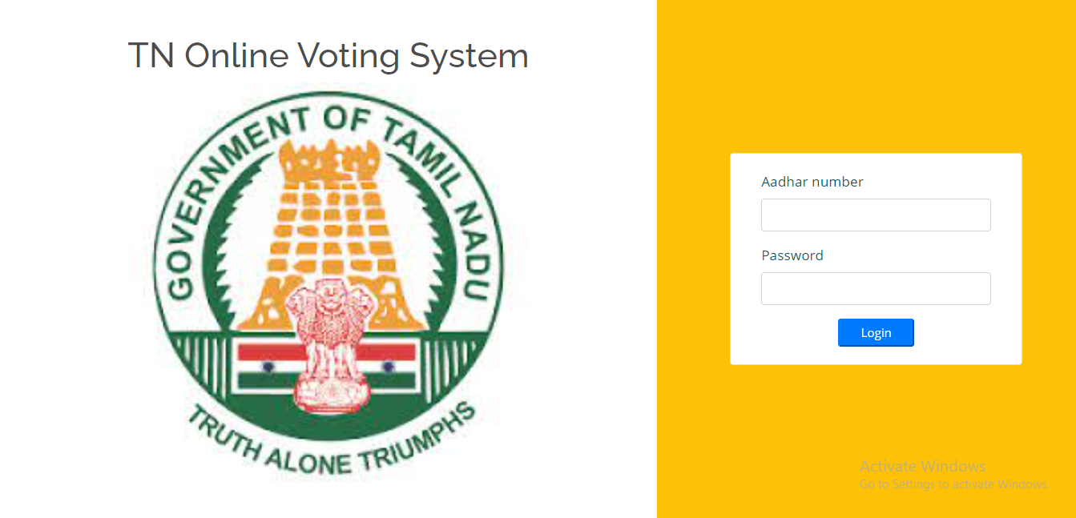
Fig(front end)

Back-end Selection:
1. Multiple user support.
2. Efficient data handling.
3. Provide inherent features for security.
4. Efficient data retrieval and maintenance.
5. Stored procedures.
6. Popularity.
7. Operating System compatible.
8. Easy to install.
9. Various drivers must be available.
10. Easy to implant with the Front-end.
According to above stated features we selected MY SQL as the backend.
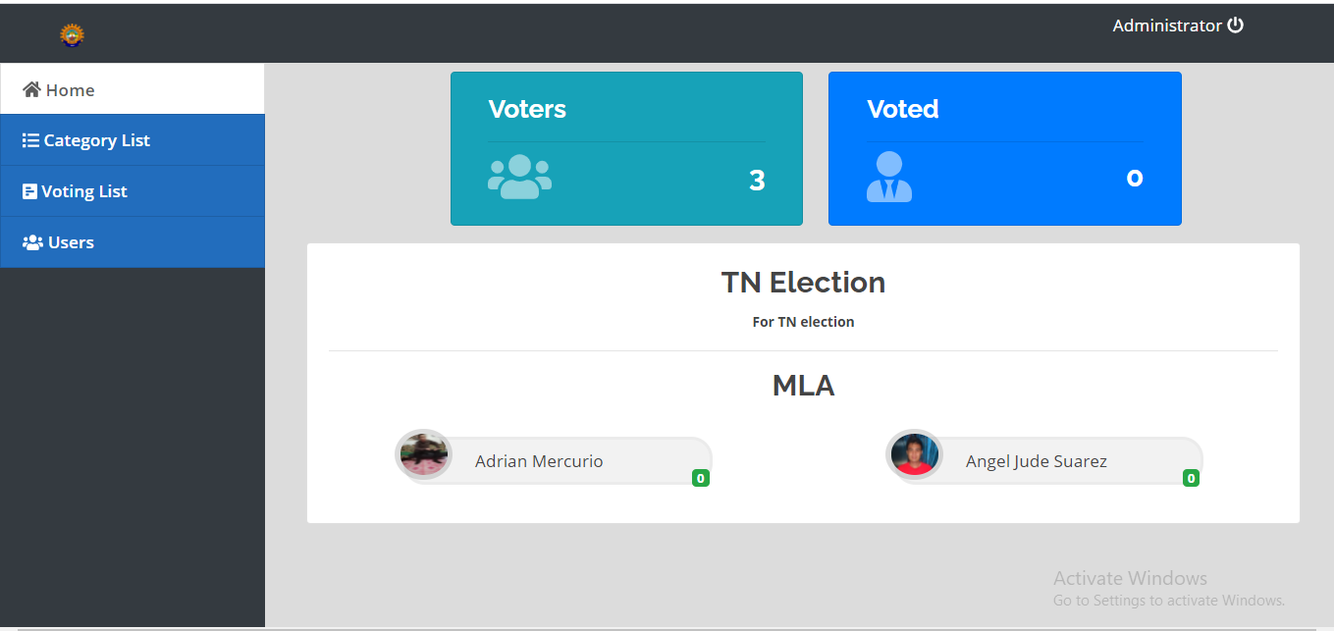
The technical feasibility is frequently the most difficult area encountered at this stage. It is essential that the process of analysis and definition be conducted in parallel with an assessment to technical feasibility. It centers on the existing computer system and to what extent it can support the proposed system.

3.2 Economical feasibility

Economic justification is generally the “Bottom Line” consideration for most systems. Economic justification includes a broad range of concerns that includes cost benefit analysis. In this we weight the cost and the benefits associated with the candidate system and if it suits the basic purpose of the organization i.e. profit making, the project is making to the analysis and design phase.
The financial and the economic questions during the preliminary investigation are
verified to estimate the following:
- The cost to conduct a full system investigation.
- The cost of hardware and software for the class of application being considered.
. The benefits in the form of reduced cost.

- The proposed system will give the minute information, as a result the
performance is improved
- This feasibility checks whether the system can be developed with the available funds. The Online voting system does not require enormous amount of money to be developed. This can be done economically if planned judicially, so it is economically feasible. The cost of project depends upon the number of man-hours required.

3.3 Operational Feasibility

It is mainly related to human organizations and political aspects. The points to be
considered are:
- What changes will be brought with the system?
- What organization structures are disturbed?
- What new skills will be required? Do the existing staff members have these
skills? If not, can they be trained in due course of time?
The system is operationally feasible as it very easy for the End users to operate it. It only needs basic information about Windows platform.

3.4 Schedule feasibility
Time evaluation is the most important consideration in the development of project. The time schedule required for the developed of this project is very important since more development time effect machine time, cost and cause delay in the development of other systems.
A reliable Online voting system can be developed in the considerable amount of time

4.DESIGN

4.1 Software Requirement Specification

4.1.1 Objective:

The main objectives of system for Online voting system are:

- The objective of Online voting system is to help the organization in automating the whole manual processing of the existing system.
- The main objective to develop the system is to make the accurate & efficient decisions in different tasks at different time at different situations. The existing system is manual so members of the unit generally face a lot of embarrassing situations many times. Now they need to automate the whole process so as to make it more easy and accurate.
- System should support multi-user environment.
- System should be fully automated.
- System should provide concrete security features like creating users and assigning privileges to users of the system.
- System should be capable to keep track of all the detailed descriptions of the client and the whole details of services offered by the client organization.
- Various outputs (reports) should be available online any time.
- System should be able to handle extremely large volumes of data (i.e. Large database support)

4.1.2 Scope:-

- Advanced technology- It is an advanced technology used now a days. It increases the E knowledge of the users which is very necessary for current generation.

- Internet: It is an online facility and hence very useful for the users.
Voters can vote from any where at any time in India.

- E-Mails: ELECTION COMMISION OF INDIA can send the error report to a particular user if he\she entered false information.

- E-SMS: People they have not internet connection they can not check the emails or not have email they can be informed by SMS on their mobile. Today many websites provide free SMS to the mobile. ELECTION COMMISION OF INDIA can use these to send any information.

4.1.3 Advantages:

- Fast and easy service.
- The online voting system provides a less time consuming .
- It reduces the paper work and makes the work less tedious for ELESTION COMMISION.
- It is a better way for voting.
- By this voting percentage will increase drastically.
Voter has no need to go to any polling booth ,so it is easy to use.
4.1.4 Technologies to be used:-
This project will be a Web application to be developed in PHP having
- Database Design (My SQL)
- Form Design (HTML 4.0)
- Coding (PHP)
- Testing (XAMP SERVER)
- Reporting Tool (Data Report)

    - OVERVIEW:

1. Requirements:

• FUNCTIONAL REQUIREMENTS:
- Registration of the voter is done by ELECTION COMMISION OF INDIA.
- ELECTION COMMISION OF INDIA can change the information any time if required.
- Registration of the Voter depends upon the information filled by the user.
- Voter is given a unique ID and PASSWORD.
- Voter can give vote after login and entering the ID and PASSWORD.
- In the DATABASE information of every voter is stored.
- Database shows the information of every user.

• NON-FUNCTIONAL REQUIREMENTS:
- Secure access of confidential data (user’s details). SSL can be used.
- 24 X 7 availability.
- Better component design to get better performance at peak time.
- Flexible service based architecture will be highly desirable for future extension

2. Project Requirements
Hardware Requirements (Processor RAM Disk Space)
Pentium II, Pentium III, Pentium IV, Higher 64 Mb or Higher 130 Mb
Software Requirements (Operating System Database)
Win-98, Win-XP, Linux, My SQL

3. Software interface:

• Client on Internet: Web Browser, Operating System (Windows)
. Client on intranet: Client Software, Web Browser, Operating System (Windows).

• Web Server: WAMP Server, Operating System (Windows)

• Data Base server: MYSQL, Operating System (Windows)
4. Communication interface:

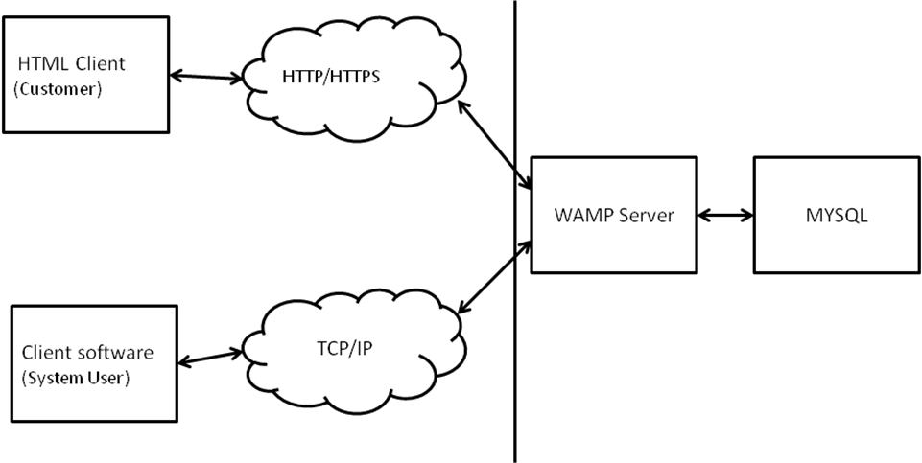

HTML Client

Client side Application server Database server

The above diagram shows the connectivity between the client side, application server and database server. The client or customer can access the HTML server or client software. These are connected to the Wamp Server (WAMP) by a TCP/IP which is a communication protocol used to connect the teachers or parents to the internet. This WAMP Server now directly communicates with the database made in MYSQL. All the enquires or data will be retrieved from the database

4.1.6 Summary:

“ONLINE VOTING SYSTEM” is an online voting technique. It is based on the other online services like “ONLINE RESERVATION SYSTEM” .In this system people who have citizenship of INDIA and whose age is above 18 years of any sex can give his\her vote online without going to any polling booth. There is a DATABASE which is maintained by the ELECTION COMMISION OF INDIA in which all the names of voter with complete information is stored.

In “ONLINE VOTING SYSTEM” a voter can use his\her voting right online without any difficulty. He\She has to fill a registration form to register himself\herself. All the entries is checked by the DATABASE which has already all information about the voter. If all the entries are correct then a USER ID and PASSWORD is given to the voter, by using that ID and PASSWORD he\she can use his\her vote. If conditions are wrong then that entry will be discarded.

4.2 Data Flow Diagram: DFD LEVEL 1:
User
or Administrator

Output

System

DFD Level-0
The above diagram is a 0-level DFD that only shows the flow of data between the various and the system. In online voting system the Administrator is the controller of the system and all the decisions are made by him. The Administrator can handle the entire voter and their details, voting details etc. and view details of them and he can update that detail also.
DFD: Level 1:-

Login
Process

Voting
Process

Voter information checking process

Voter
Registration
Process

Final
Report

DFD Level 1
The above shown diagram is a 1-level Data Flow Diagram for the Online voting system. According to this DFD various process are done after login process. The Administrator can register voter. The ELECTION COMMISION can register the voters and voter can use their voting rights. The voter can view the final report after giving vote..
DFD: Level 2
2.1: DFD: Level 2.1:
The above shown diagram is a 2.1 level Data Flow Diagram for the Online voting system. According to this DFD. The Administrator can register the voter information. Administrator can allow or denies the voter. A voter can give vote if all the information filled by him\her are correct.
Administrator
Voter

Final
Result

Voting process

Voter Registration

Information checking
administrators

Login Process

Login

voter data stored data voting data final result
ElectionCommission

5.SYSTEM MODLING

Entity Relationship Diagram
Registration
Admin.

Fail
VOTER

id
Pass
Login

VOTING

Voting Report

Report View

Fig.- E-R Diagram
The entity relationship diagram shows the relationship between the various users and their attributes. There is a relationship between the election commission and voter.
The VOTER has different attributes to store their data to data base are follows:-
1. Name-Name contain first name, middle name, last name.
2. Age (should be above 18 years)
3. City
4. State
5. Father’s/Husband Name
6. Address
7. Phone number (Permanent)
8. Phone number (Mobile)
9. Email address
Class diagram-:
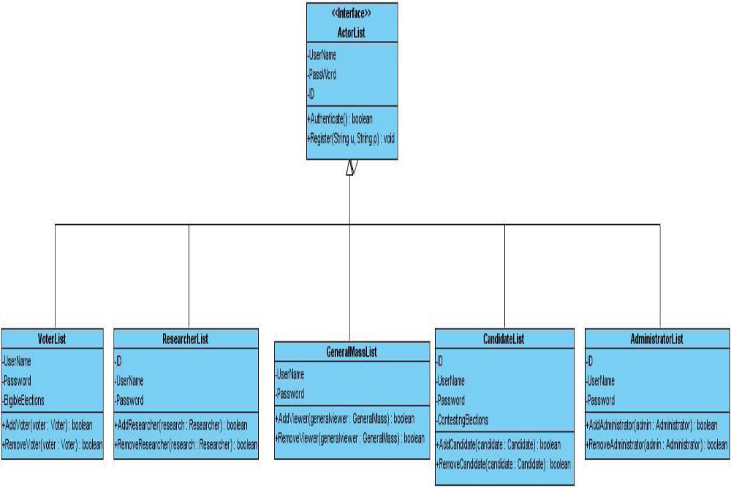

Fig: Relationship between the interface Actor List and its inheriting classes

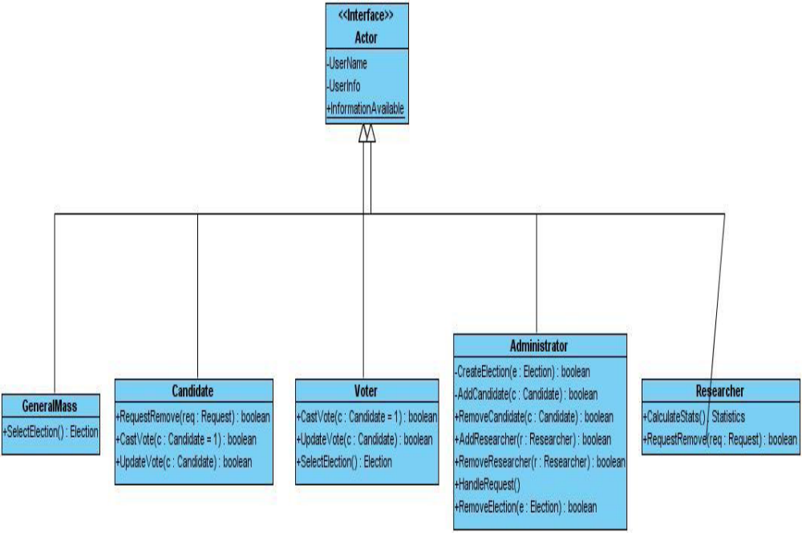

Fig: Association between Actor interface and other inheriting classes
Registration, login, and logoff modules act as mediator.

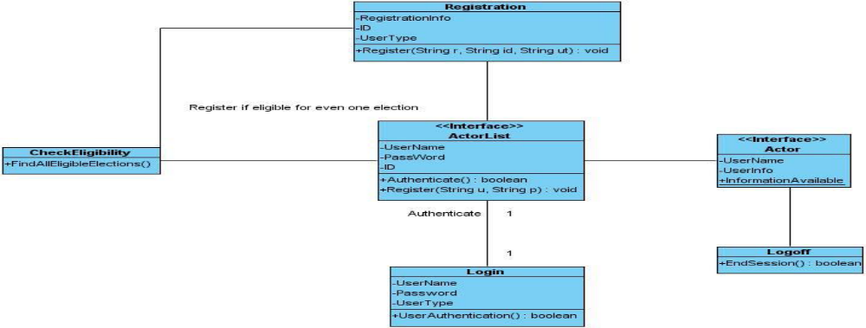
Fig: Association between Registration, Actor List, Login, Logoff

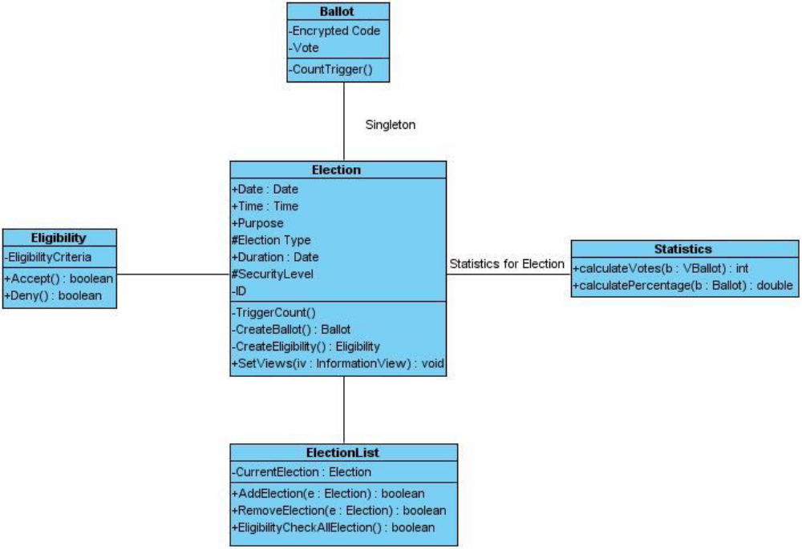
Fig: Association between Election and Ballot (Flyweight, Singleton)

Data Base Tables:-
Admin Table:-
S. No. | Field Name | Data Type | Description
 | Login id | Varchar | Login id for Admin.(Primary key)
 | Password | Varchar | Password for Login
 | Name | Varchar | Name of the Administrator

Voter information Data Table:-

S. No. | Field Name | Data Type | Description
 | Login id | Varchar | Login id for Voter(Primary key)
 | Password | Varchar | Password for Login
 | Name | Varchar | Name of the voter
 | Father’s/Husband name | Varchar | Voter’s father or  husband name
 | House no. | Varchar | House no. of voter
 | Address | Varchar | Address of voter
 | City | Varchar | City of voter
 | Mobile | Varchar | Mobile No of voter
 | E-Mail | Varchar | E-Mail of voter

CONCLUSION:
This Online Voting system will manage the Voter’s information by which voter can login and use his voting rights. The system will incorporate all features of Voting system. Its provide the tools for maintaining voter’s vote to every party and it count total no. of votes of every party. There is a DATABASE which is maintained by the ELECTION COMMISION OF INDIA in which all the names of voter with complete information is stored.
In this user who is above 18 year’s register his/her information on the database and when he/she want to vote he/she has to login by his id and password and can vote to any party only single time. Voting detail store in database and the result is displayed by calculation. By online voting system percentage HPof voting is increases. It decreases the cost and time of voting process. It is very easy to use and It is vary less time consuming. It is very easy to debug.
CODING LANGUAGE:
- JAVASCRIPT
- PHP
DATABASE CONNECTION:

<!DOCTYPE html>
<html lang="en">
<head>
<meta charset="utf-8">
<meta content="width=device-width, initial-scale=1.0" name="viewport">
<title>Voting System</title>
<?php
session_start();
if(!isset($_SESSION['login_id']))
header('location:login.php');
include('./header.php');
// include('./auth.php');
?>
</head>
<style>
body{
background: #80808045;
}
</style>
<body>
<?php include 'topbar.php' ?>
<?php include 'navbar.php' ?>
<div class="toast" id="alert_toast" role="alert" aria-live="assertive" aria-atomic="true">
<div class="toast-body text-white">
</div>
</div>
<main id="view-panel" >
<?php $page = isset($_GET['page']) ? $_GET['page'] :'home'; ?>
<?php include $page.'.php' ?>
</main>
<div id="preloader"></div>
<a href="#" class="back-to-top"><i class="icofont-simple-up"></i></a>
<div class="modal fade" id="confirm_modal" role='dialog'>
<div class="modal-dialog modal-md" role="document">
<div class="modal-content">
<div class="modal-header">
<h5 class="modal-title">Confirmation</h5>
</div>
<div class="modal-body">
<div id="delete_content"></div>
</div>
<div class="modal-footer">
<button type="button" class="btn btn-primary" id='confirm' onclick="">Continue</button>
<button type="button" class="btn btn-secondary" data-dismiss="modal">Close</button>
</div>
</div>
</div>
</div>
<div class="modal fade" id="uni_modal" role='dialog'>
<div class="modal-dialog modal-md" role="document">
<div class="modal-content">
<div class="modal-header">
<h5 class="modal-title"></h5>
</div>
<div class="modal-body">
</div>
<div class="modal-footer">
<button type="button" class="btn btn-primary" id='submit' onclick="$('#uni_modal form').submit()">Save</button>
<button type="button" class="btn btn-secondary" data-dismiss="modal">Cancel</button>
</div>
</div>
</div>
</div>
</body>
<script>
window.start_load = function(){
$('body').prepend('<di id="preloader2"></di>')
}
window.end_load = function(){
$('#preloader2').fadeOut('fast', function() {
$(this).remove();
})
}
window.uni_modal = function($title = '' , $url=''){
start_load()
$.ajax({
url:$url,
error:err=>{
console.log()
alert("An error occured")
},
success:function(resp){
if(resp){
$('#uni_modal .modal-title').html($title)
$('#uni_modal .modal-body').html(resp)
$('#uni_modal').modal('show')
end_load()
}
}
})
}
window._conf = function($msg='',$func='',$params = []){
$('#confirm_modal #confirm').attr('onclick',$func+"("+$params.join(',')+")")
$('#confirm_modal .modal-body').html($msg)
$('#confirm_modal').modal('show')
}
window.alert_toast= function($msg = 'TEST',$bg = 'success'){
$('#alert_toast').removeClass('bg-success')
$('#alert_toast').removeClass('bg-danger')
$('#alert_toast').removeClass('bg-info')
$('#alert_toast').removeClass('bg-warning')
if($bg == 'success')
$('#alert_toast').addClass('bg-success')
if($bg == 'danger')
$('#alert_toast').addClass('bg-danger')
if($bg == 'info')
$('#alert_toast').addClass('bg-info')
if($bg == 'warning')
$('#alert_toast').addClass('bg-warning')
$('#alert_toast .toast-body').html($msg)
$('#alert_toast').toast({delay:3000}).toast('show');
}
$(document).ready(function(){
$('#preloader').fadeOut('fast', function() {
$(this).remove();
})
})
</script>
</html>

<!DOCTYPE html>
<html lang="en">

<head>
<meta charset="utf-8">
<meta content="width=device-width, initial-scale=1.0" name="viewport">

<title>Login | Voting System</title>

<?php include('./header.php'); ?>
<?php
session_start();
if(isset($_SESSION['login_id']))
header("location:index.php?page=home");
?>

</head>
<style>
body{
width: 100%;
height: calc(100%);
/*background: #007bff;*/
}
main#main{
width:100%;
height: calc(100%);
background:white;
}
#login-right{
position: absolute;
right:0;
width:40%;
height: calc(100%);
background:white;
display: flex;
align-items: center;
}
#login-left{
position: absolute;
left:0;
width:60%;
height: calc(100%);
background:white;
display: flex;
align-items: center;
}
#login-right .card{
margin: auto
}
.logo {
margin: auto;
font-size: 8rem;
/*background: #00000061;*/
/*padding: .5em 0.8em;*/
/*border-radius: 50% 50%;*/
color: #000000b3;
}
</style>

<body>

<main id="main" class=" alert-info">
<div id="login-left">
<div class="logo">
<h1>TN Online Voting System</h1>
<img src="images.jfif" alt="..." width="100%">
</div>
</div>
<div id="login-right" class="bg-warning">
<div class="card col-md-8">
<div class="card-body">
<form id="login-form" >
<div class="form-group">
<label for="username" class="control-label">Aadhar number</label>
<input type="number" id="username" name="username" class="form-control">
</div>
<div class="form-group">
<label for="password" class="control-label">Password</label>
<input type="password" id="password" name="password" class="form-control">
</div>
<center><button class="btn-sm btn-block btn-wave col-md-4 btn-primary">Login</button></center>
</form>
</div>
</div>
</div>

</main>

<a href="#" class="back-to-top"><i class="icofont-simple-up"></i></a>

</body>
<script>
$('#login-form').submit(function(e){
e.preventDefault()
$('#login-form button[type="button"]').attr('disabled',true).html('Logging in...');
if($(this).find('.alert-danger').length > 0 )
$(this).find('.alert-danger').remove();
$.ajax({
url:'ajax.php?action=login',
method:'POST',
data:$(this).serialize(),
error:err=>{
console.log(err)
$('#login-form button[type="button"]').removeAttr('disabled').html('Login');

},
success:function(resp){
if(resp == 1){
location.href ='index.php?page=home';
}else if(resp == 2){
location.href ='voting.php';
}else{
$('#login-form').prepend('<div class="alert alert-danger">Username or password is incorrect.</div>')
$('#login-form button[type="button"]').removeAttr('disabled').html('Login');
}
}
})
})
</script>
</html>

